CSA0501-DATABASE MANAGEMENT SYSTEMS
LAB EXPERIMENTS DATE: 14-07-2026

EXPERIMENT 8 - Query with Sub Query& Correlated Query

AIM:

To perform Subquery and Correlated Subquery operations on the given tables.

PROCEDURE:
- Open MySQL Workbench and select the required database.
- Execute SQL statements containing subqueries.
- Execute correlated subqueries using the EXISTS clause.
- Verify the results returned by each query.

PROGRAM:

1. Display faculty whose age is greater than the average faculty age. (Sub Query)
SELECT *
FROM FACULTY
WHERE Age >
(
SELECT AVG(Age)
FROM FACULTY
);
OUTPUT:
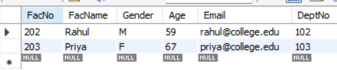

2. Display faculty who guide more than one intern. (Sub Query)
SELECT *
FROM FACULTY
WHERE FacNo IN
(
SELECT FacNo
FROM INTERN
GROUP BY FacNo
HAVING COUNT(InternID) > 1
);
OUTPUT:
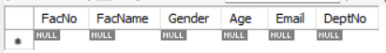

3. Display the most recently added faculty (highest Faculty ID). (Sub Query)
SELECT *
FROM FACULTY
WHERE FacNo =
(
SELECT MAX(FacNo)
FROM FACULTY
);
OUTPUT:
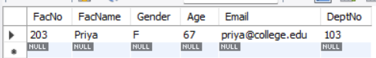

4. 4. Display interns whose age is greater than the average age of interns in their faculty. (Correlated Sub Query)
SELECT *
FROM INTERN I
WHERE Age >
(
SELECT AVG(Age)
FROM INTERN
WHERE FacNo = I.FacNo
);
OUTPUT:
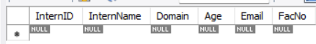

5. Display faculty who have at least one intern. (Correlated Query using EXISTS)
SELECT *
FROM FACULTY F
WHERE EXISTS
(
SELECT *
FROM INTERN I
WHERE I.FacNo = F.FacNo
);
OUTPUT:
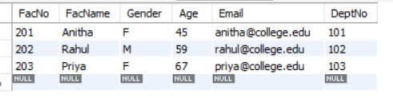

6.Display projects assigned to interns older than 20 years. (Sub Query)
SELECT *
FROM PROJECT
WHERE InternID IN
(
SELECT InternID
FROM INTERN
WHERE Age > 20
);
OUTPUT:
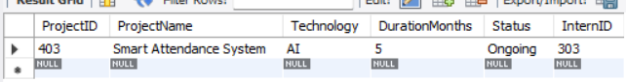

RESULT:

The Subquery and Correlated Subquery operations were executed successfully, and the required records were retrieved from the tables.

